Creating Accounts for Providers/Schedulers

- From Admin Tools, click on “Manage Providers”
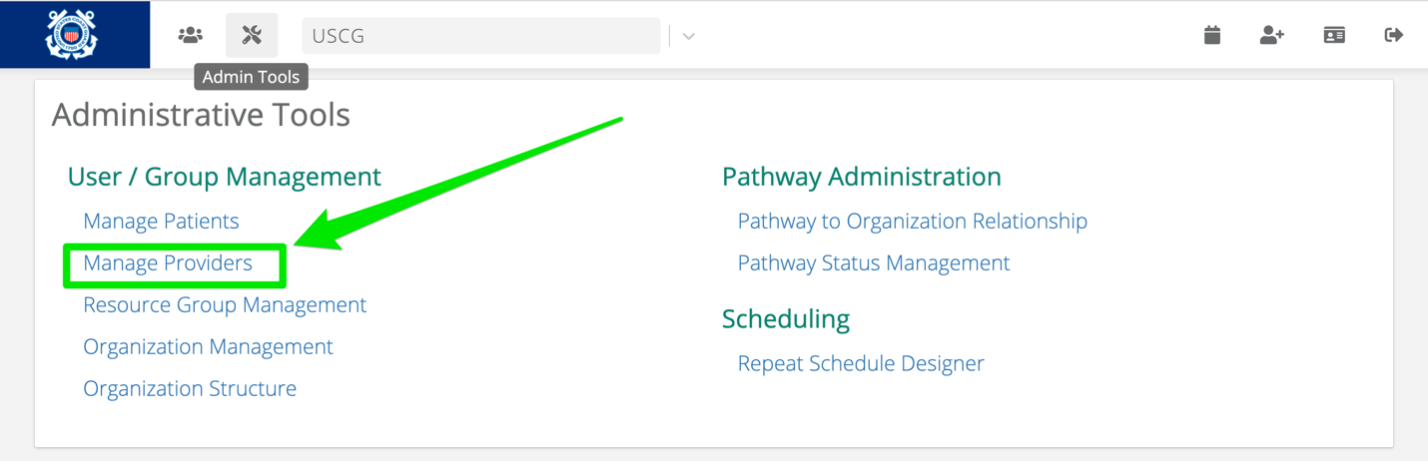
- Click on “Add Provider” Button
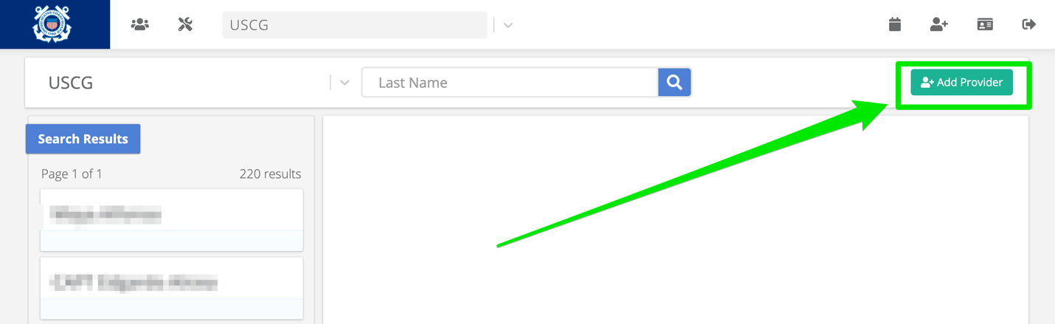
- Fill out these 5 fields
  - First Name, Last Name, Username, Email, Send Activation Email
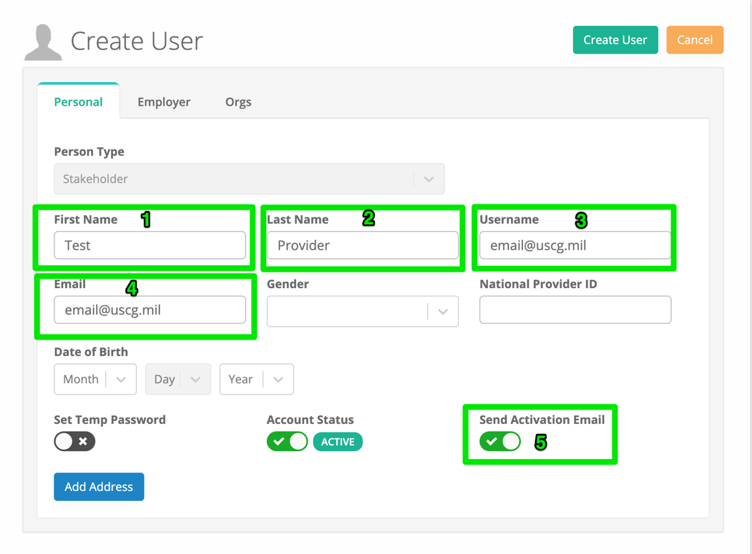
- Click on the “Orgs” Tab
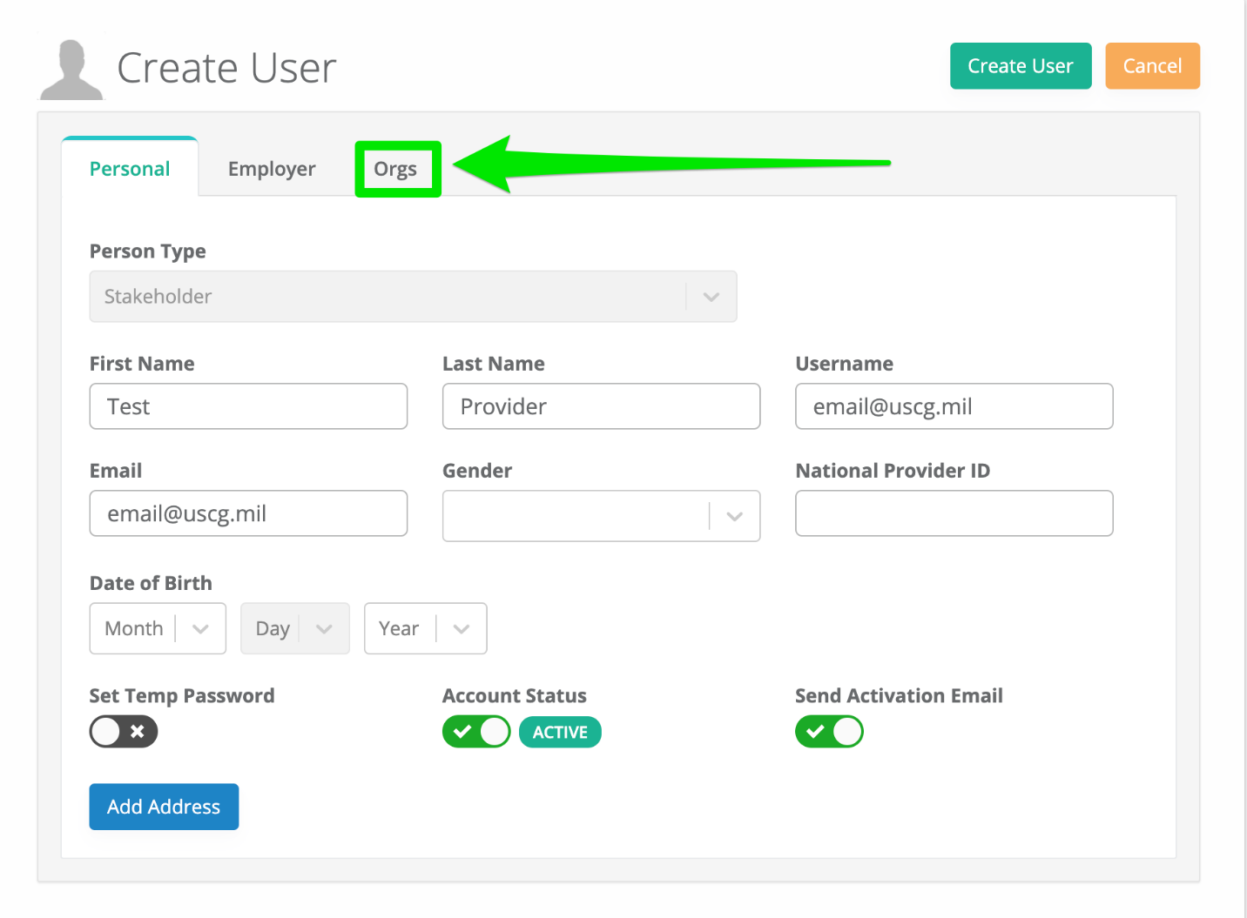
- Select “USCG” Org. Select “Provider” as the role. Then click “Create User”
